# Project Name: Team Budget Planner.

## GitHub Link:

### <https://github.com/tamasjit/myjavaproject/tree/master/Phase%204/Phase-4_Practice_Project/q2_budget_Planner>

## Output:

### Landing Page:

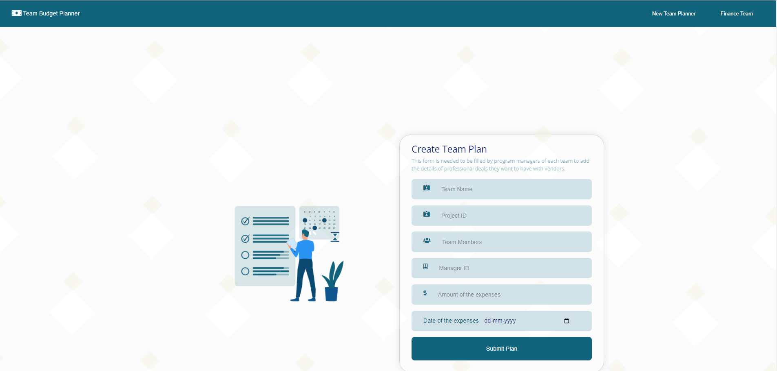

### Table:

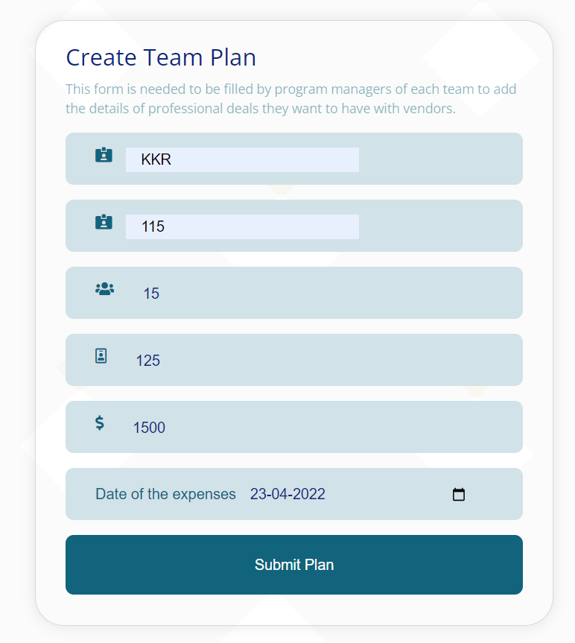

### Validation:

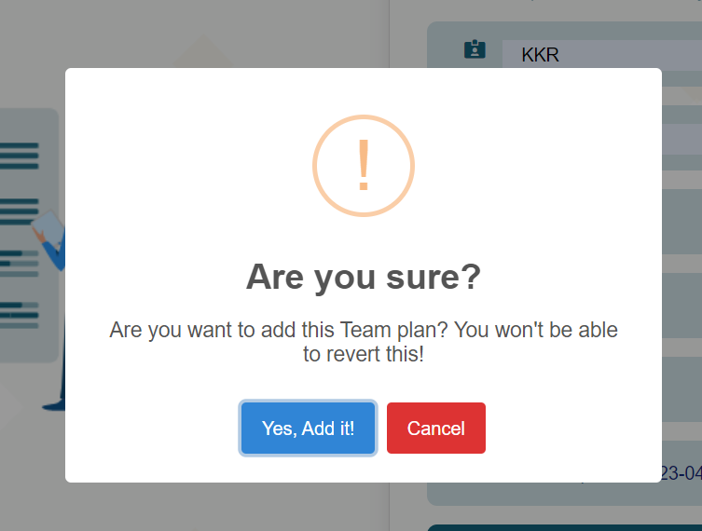

### Finance Page:

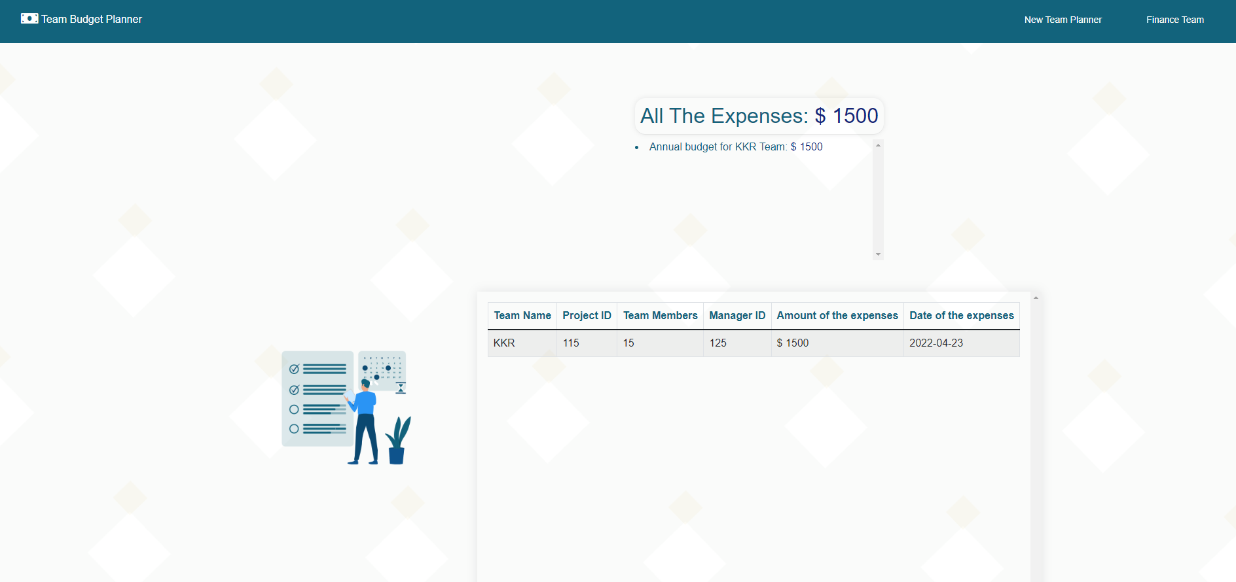

### Added more entries:

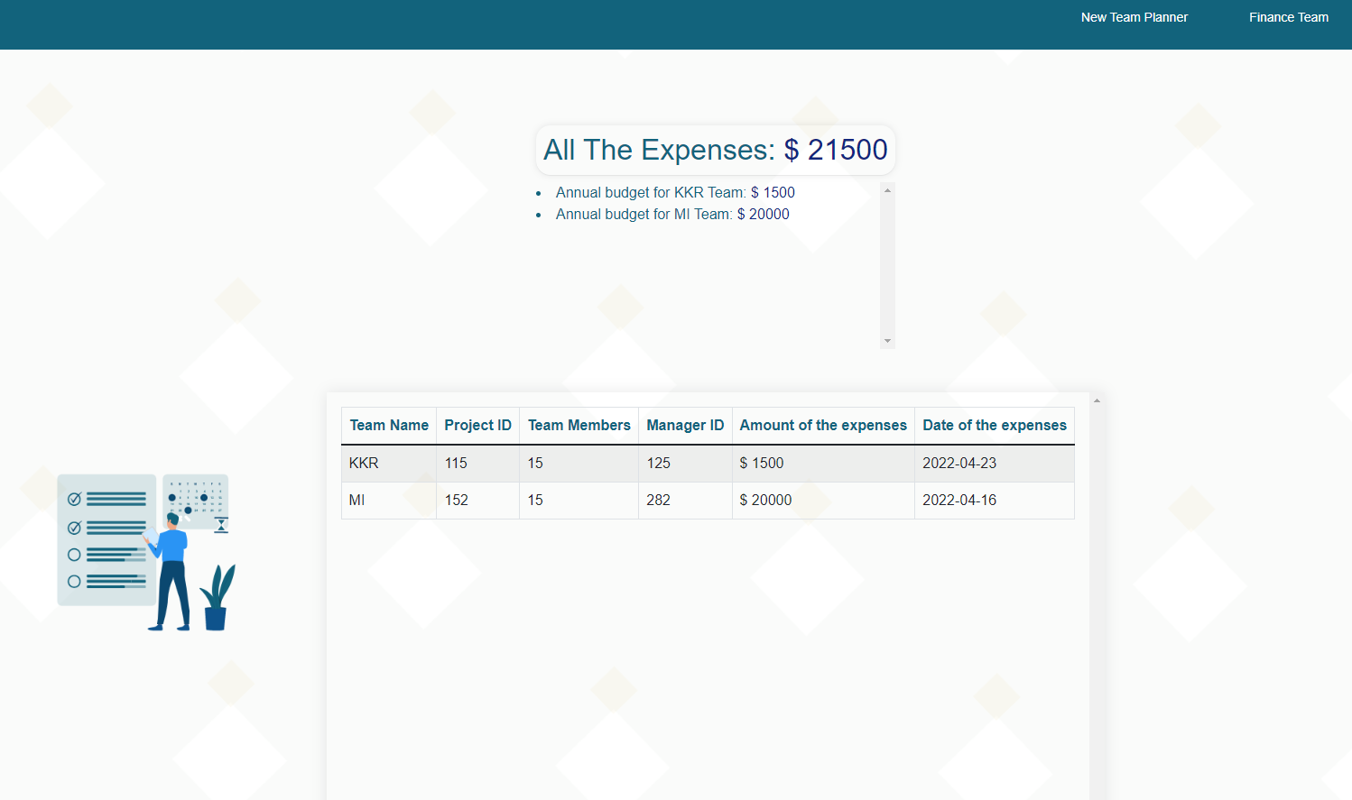

### If table not propperly filled:

